PART IV. RESOURCE REQUIREMENTS
For an updated and relatively accurate cost estimate, CSC has conducted a market study on the indicative costs of all proposed items reflected on this ISSP.
A. DEPLOYMENT OF ICT EQUIPMENT AND SERVICES
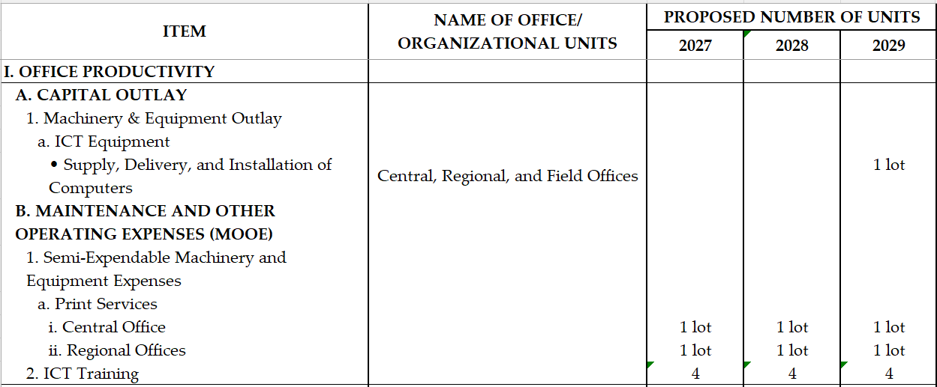

PART IV. RESOURCE REQUIREMENTS
A. DEPLOYMENT OF ICT EQUIPMENT AND SERVICES
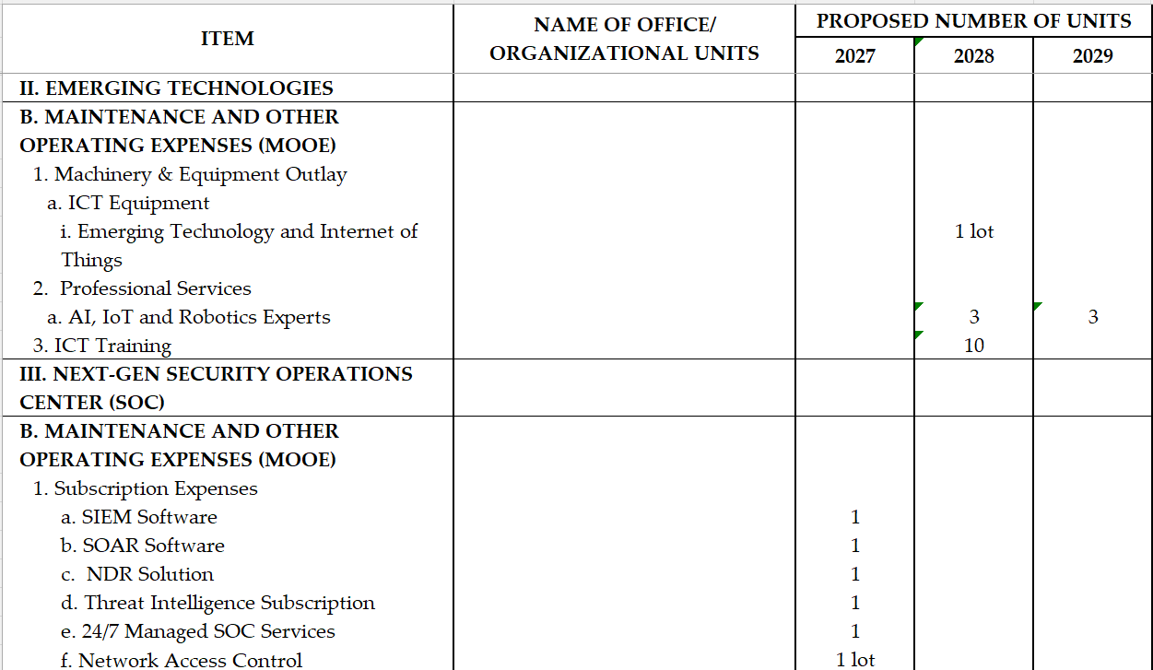
PART IV. RESOURCE REQUIREMENTS
A. DEPLOYMENT OF ICT EQUIPMENT AND SERVICES
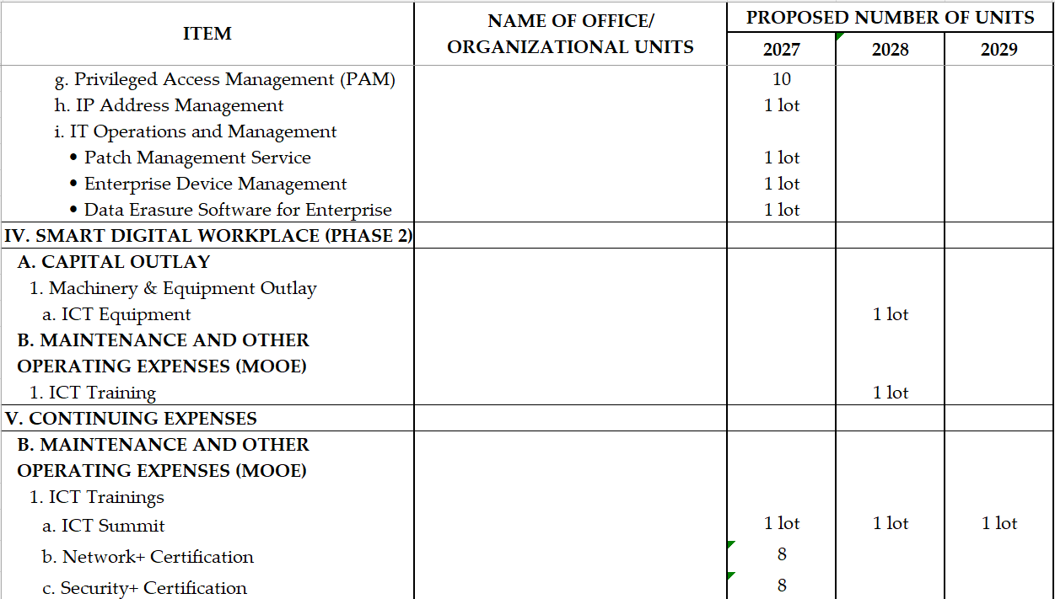
PART IV. RESOURCE REQUIREMENTS
- DEPLOYMENT OF ICT EQUIPMENT AND SERVICES
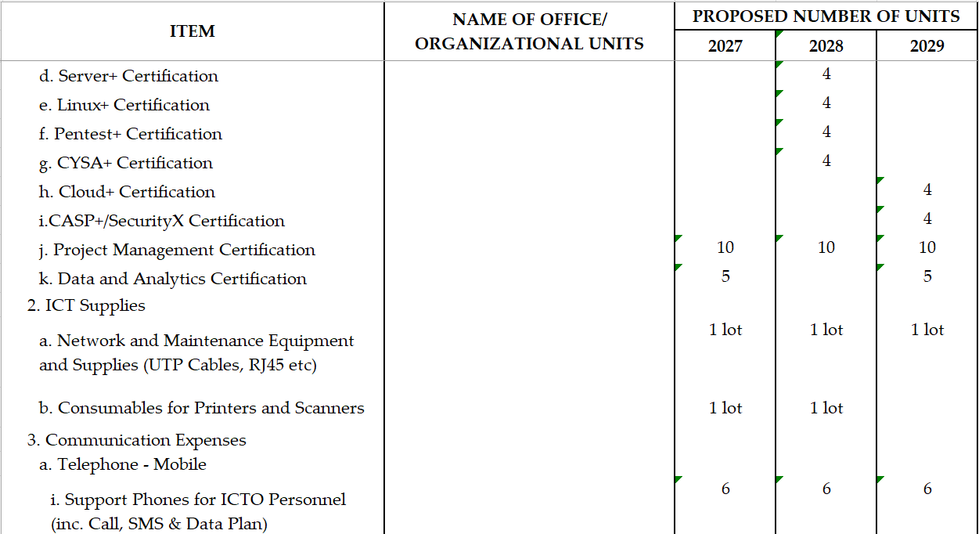
PART IV. RESOURCE REQUIREMENTS
A. DEPLOYMENT OF ICT EQUIPMENT AND SERVICES
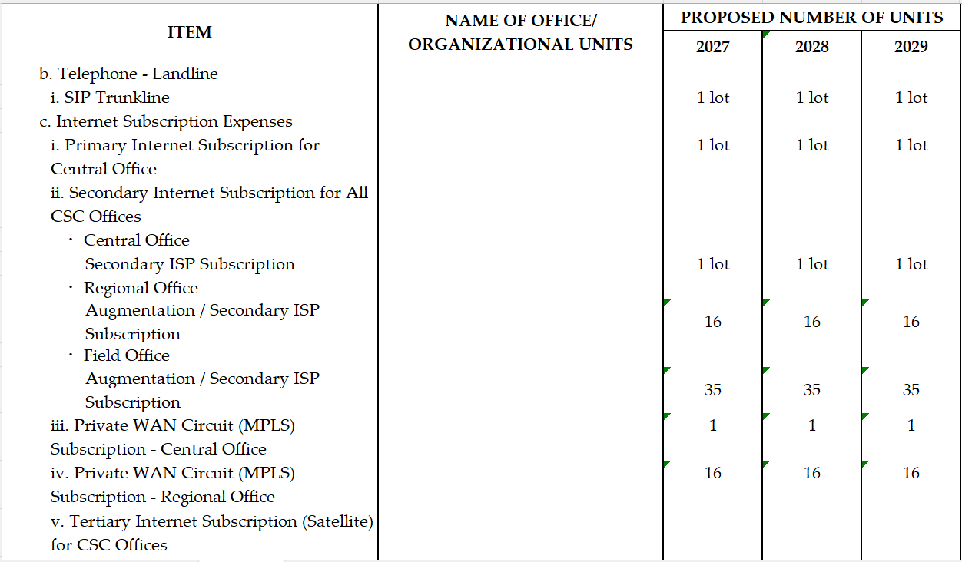
PART IV. RESOURCE REQUIREMENTS
A. DEPLOYMENT OF ICT EQUIPMENT AND SERVICES
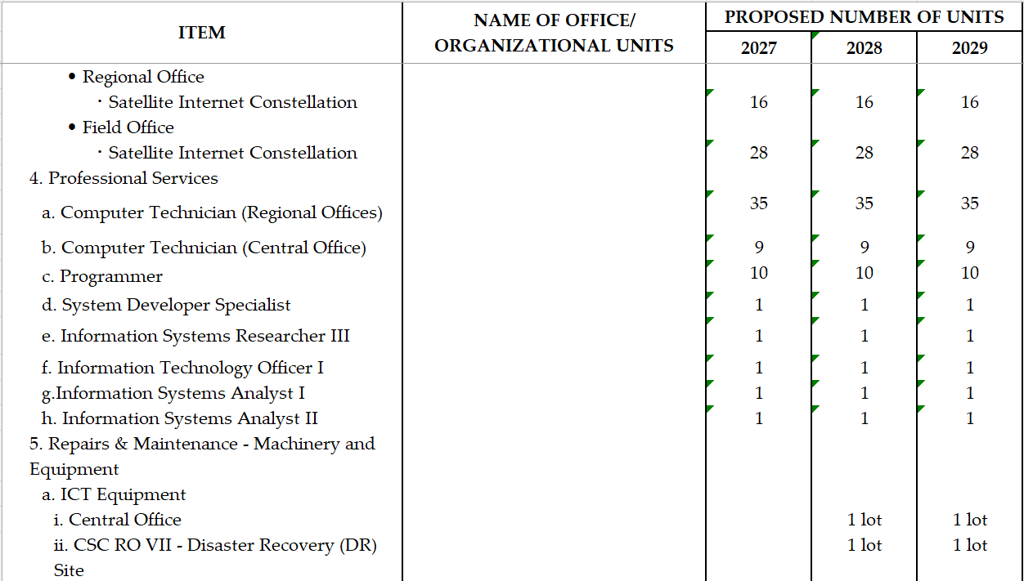
PART IV. RESOURCE REQUIREMENTS
A. DEPLOYMENT OF ICT EQUIPMENT AND SERVICES
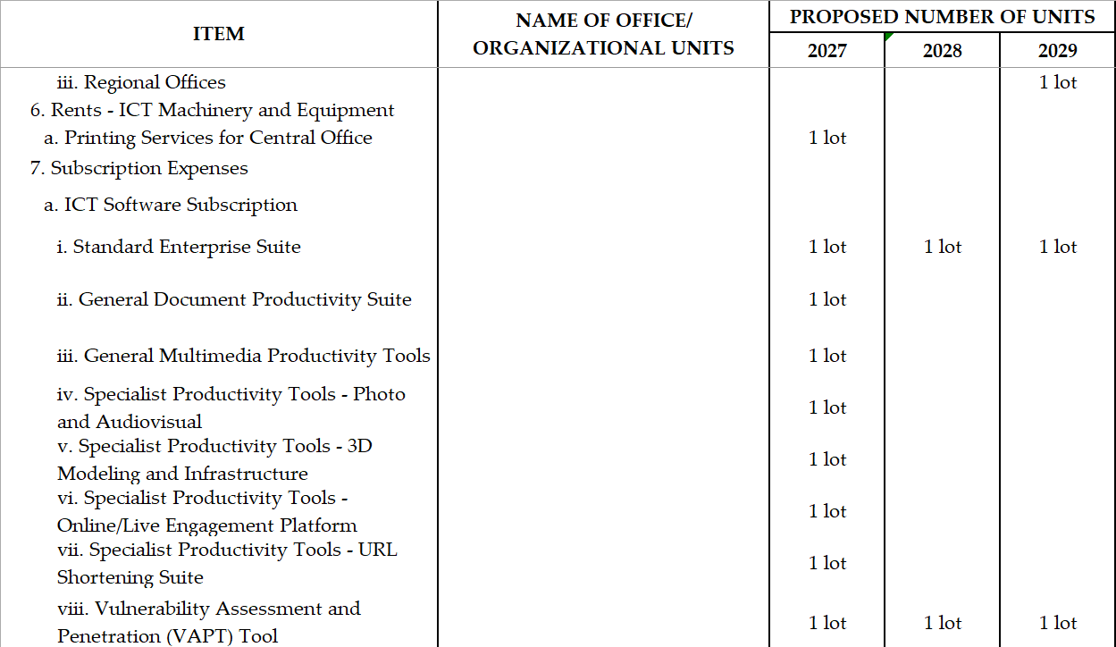
PART IV. RESOURCE REQUIREMENTS
A. DEPLOYMENT OF ICT EQUIPMENT AND SERVICES
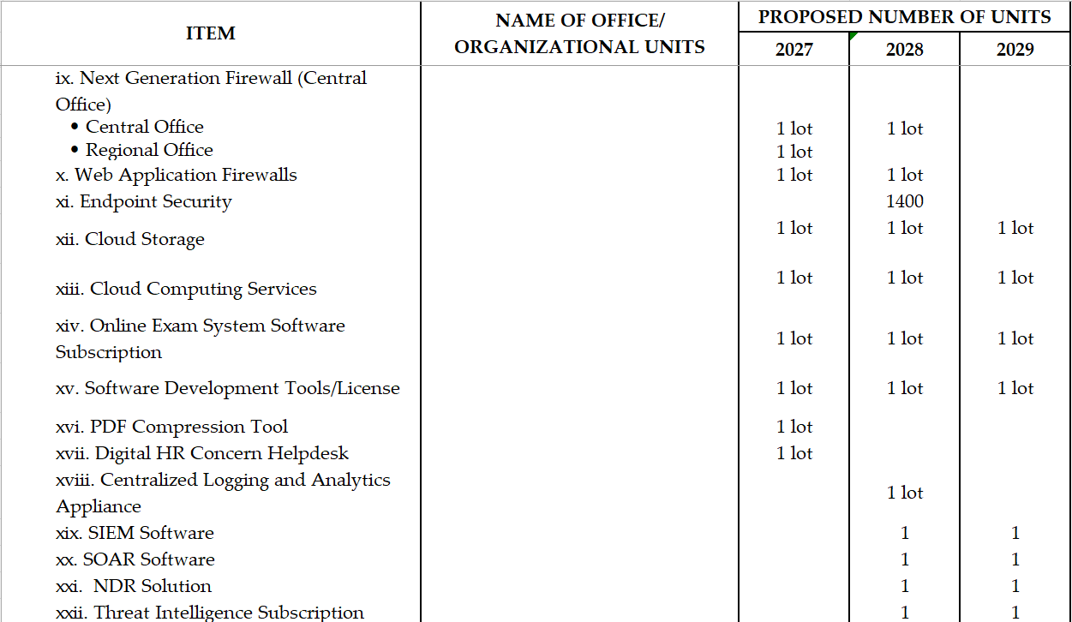
PART IV. RESOURCE REQUIREMENTS
A. DEPLOYMENT OF ICT EQUIPMENT AND SERVICES
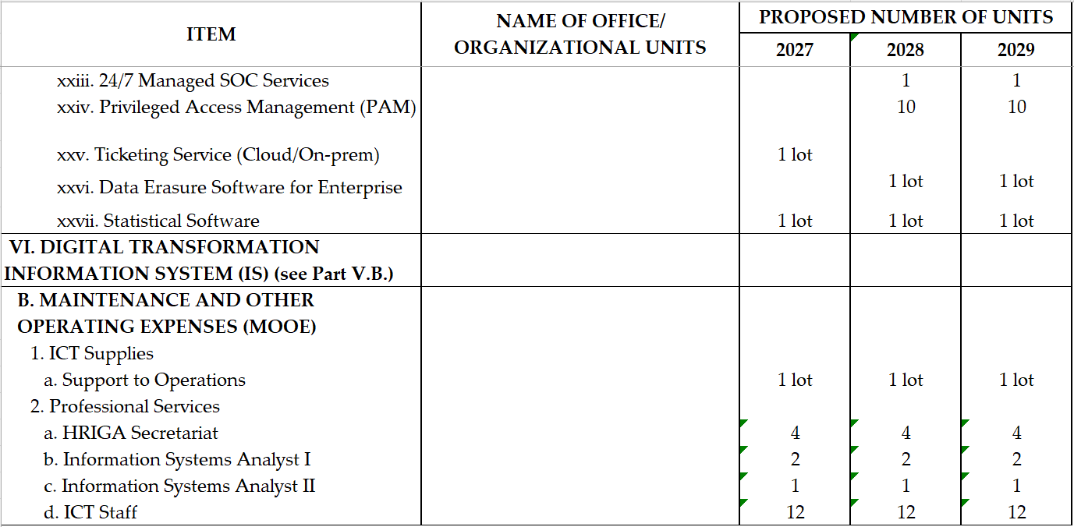
PART IV. RESOURCE REQUIREMENTS
B. ICT ORGANIZATIONAL STRUCTURE
B.1. EXISTING ICT ORGANIZATIONAL STRUCTURE
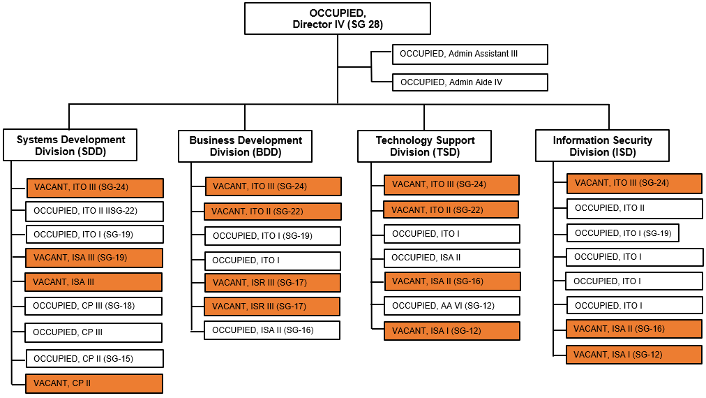
*No organic ICT Position in the Regional Offices, only ICT Focal Persons
PART IV. RESOURCE REQUIREMENTS
B.2. PROPOSED ICT ORGANIZATIONAL STRUCTURE
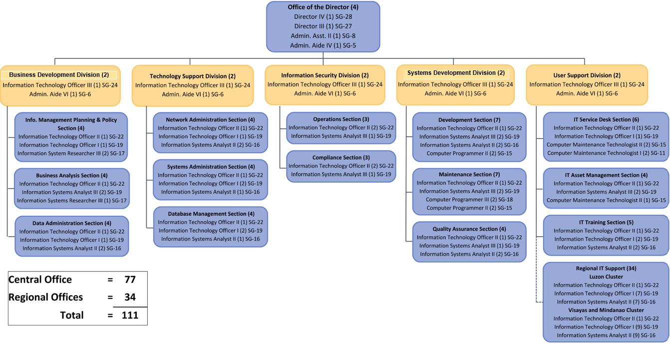

PART IV. RESOURCE REQUIREMENTS
B.2. PROPOSED ICT ORGANIZATIONAL STRUCTURE
INFORMATION AND COMMUNICATIONS TECHNOLOGY OFFICE (ICTO)
Manages the day-to-day Information and Communications Technology (ICT) operations and ensures the efficiency delivery of ICTO’s mandated services and committed targets; Responsible for establishing, monitoring, and maintaining information technology systems and services; Determines information technology requirements to enhance the efficiency of work processes and facilitate the delivery of services to internal and external clients despite challenging conditions; Identifies digital solutions (e.g. cloud-based data storage, digitization of records, data security, etc.) that will address identified requirements for work process enhancement; Undertakes maintenance of in-house systems, including monitoring and evaluation of their performance; and Establishes and maintains linkages, development cooperation and partnership with local and international
BUSINESS DEVELOPMENT DIVISION (BDD)
Formulates IM Strategic Plan for the use of IT-enabled improvements;
Conducts IT research;
Formulates policies and standards that will provide overall guidance and direction in the development and implementation of IT activities in the Agency;
Conducts strategic assessments to identify future Institutional Capacity Development (ICD) needs;
Manages and monitors ICD performance improvement targets;
Assists implementing offices in analyzing needs and in the preparation of the Terms of Reference (TOR);
Maintains process and data models; and
Monitors compliance with data policies, procedures, and operating standards and guidelines.
TECHNOLOGY SUPPORT DIVISION (TSD)
Manages and maintains the wide area network of the Agency (voice and data);
Manages and maintains the organization servers;
Provides support for application deployment;
Manages the security and integrity of technology systems;
Manages and maintains the physical databases; and
Ensures compliance with backup operating standards and guidelines.
SYSTEM DEVELOPMENT DIVISION (SSD)
Institutes process improvements/ reengineering of process with enabling technologies;
Develops and maintains enterprise-wide and individual unit applications to ensure alignment with business goals;
Evaluates/audits all deployed applications; performs applications testing and quality management; and
Develops and maintains the organization’s website
USER SUPPORT DIVISION (USD)
Develops systematic approach in assisting users in the resolution of IT problems, identify enhancements and training needs by analyzing these problems;
Manages ICT resource capacity and ensure optimized utilization of these resources;
Coordinates ICT-related procurements and manage software licensing and network infrastructure inventory, manage ICT-related billings;
Develops IT Training Program and conduct training to improve the IT proficiency of employees.

INFORMATION SECURITY DIVISION (ISD)
Establish, implement and enforce ICT security-related policies and procedures that reduce operational risks;
Administers and review the conduct of specific security procedures of those assigned to specific security duties;
Investigate security issues and threats.
Oversees compliance with all relevant ICT laws, regulations, and international standards and conventions concerning cybersecurity, data privacy, and related concerns;
Undertake security training, advocacy promotion and awareness raising campaigns concerning cybersecurity.

